Mark J. Le Mire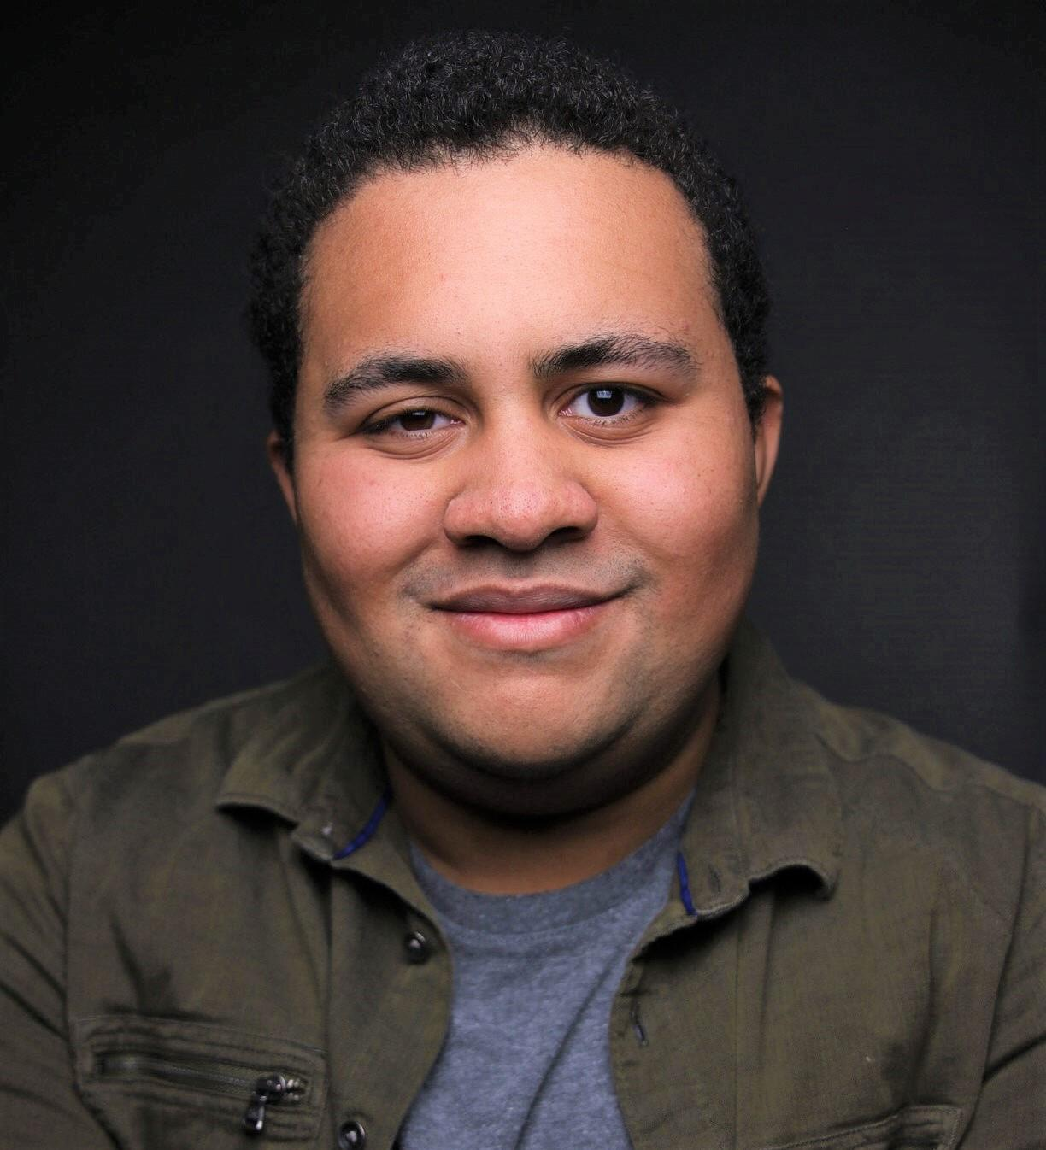

**Vocal Range: A2 - A4**

**Height: 5’8**

**Phone:** (+1) 248-250-3297

**Email:** [Mlemire06@gmail.com](mailto:Mlemire06@gmail.com)

**Theatre**

| *A Little Night Music* | Carl Magnus | Oakland University/Karen Sheridan |
| --- | --- | --- |
| *A New Brain* | Mr. Bungee | Oakland University/Rachel M. Stevens |
| *The Trojan Women* | Poseidon | Hydrama, Greece/Lynnae Lehfeldt |
| *In Pieces* | Charlie | Oakland University/Cayla Stus |
| *Hastings Street* | Lenny | Plowshare Theatre/Gary Anderson |
| *I And You* | Anthony | Oakland University/Antonio Vettraino |

**Education / Training**

BFA Musical Theater Oakland University, Expected May 2023

**Voice**: Jaron M. Legrair, Elijah Caldwell, Jenna Pastuszek, Constantine Novotny, Angela Theis

**Acting**: Josh Young, Rachel M. Stevens, Emily Padgett, Karen Sheridan, Lynnae Lehfeldt, Brandon A. Wright, Monica Lopez Orozco, Milica Govich

**Dance**: Emily Padgett (Musical Theater), Denise Caston Clark (Tap), Christina Tasco (Ballet)

**Special Skills** Improve Experience, Stage Combat Experience (Hand to Hand), Piano (Basic), Harmonica (Basic, Self Taught), Golf, Boy Scout, Michigan DL, US Passport